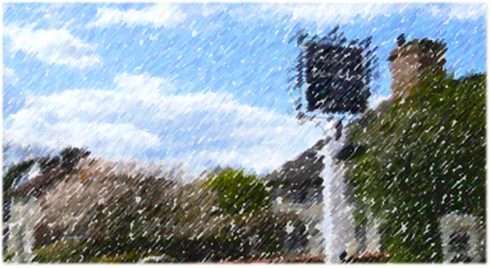SLAUGHAM PARISH COUNCIL
RECREATION COMMITTEE AGENDA
Monday 10th February 2025 5.30pm
Sports Pavilion Handcross
Email clerk@slaughampc.co.uk Website: http://www.slaughampc.co.uk _____________________________________________________________________________________
Present: Cllrs Lesley Read, Julia Elliott, Jane MacNaughton

- Apologies for absence: Ken Boyle

- To approve the minutes of the meeting held on the: 1st October 2024 Proposed Cllr Read, Cllr Elliott

- To receive declarations of interest from members in respect of any items on the agenda. NONE
- Management Committee Reports: to receive and note committee and advisory group updates – Committee to consider the RECOMMENDATIONS:

  - MacNaughton Hall Management Committee Updates/General: -
  - Sports Pavilion Management Committee Updates/General: -
    - To review security door entry system
    - Football – Handcross & Lower Beeding – Members are asked to review and accept the proposal for from the Club for use of the site 2024/25 25/26 cc’d in advance APPROVED RESOLVED

- Allotment Updates – To update members of status and progress:
  - Handcross – Rents - Not complete
  - Warninglid - Rents - Not complete
  - To update on rent increase recommended and lease agreements 2025/26 – Increases to be reviewed at a later date
- Playgrounds: To update on reports and status:
  - Slaugham – Park Road, Slaugham – No issues to report, other than lack of use
  - Handcross – Recreation Ground, Handcross - No issues to report

- HSE Risk Assessments – Committee to report on Risk Assessment Programme
Members to consider appointment of a facilities management service: The Clerk to look at facilities management outsourcing.

- Village Enhancement Projects: To update on projects
  - Public Toilets – To update on progress for renovation: Refer to Council
  - Planting Bus Stop – To update on progress: Sally is waiting on a meeting with Nymans Head Gardener

- Knapes Field: To update on projects:
  - Review Draft Management Plan: The future management plan aims to enhance the development and management of open spaces, providing recreational opportunities that can significantly improve public health and quality of life. This plan will enable the Council to identify potential funding sources for land management improvements and future initiatives. By fostering collaboration between various departments and engaging with the community, we can ensure that these open spaces meet the needs and expectations of residents. The plan will also focus on sustainable practices to maintain the ecological balance and promote environmental stewardship.
  - Members to consider conducting a survey among residents to gather input on the desired features. Due to costs it was agreed to restore the site to a field before investing in further alterations to the site. This will be reviewed again at the next meeting ahead of budgets for the main Council. The Clerk asked the committee to consider any additional costs ahead of review by the Finance Committee

- Update on the status of a request for additional permissive/public footpath linking St Martin, Park Road, Knapes Field. The Clerk provided an update on the plans for clearing site see Item 11.1 – Lesley to contact County with regards to the additional permissive path from St Martins.

- Other recreational projects in progress:

- Matters for future discussion-

- Date of Next Meeting - TBA

