

SLAUGHAM PARISH COUNCIL
Meeting meeting of the Parish Council Minutes
Thursday 25th September 2025 Sports Pavilion, High Street, Handcross
Sally Mclean - Clerk to the Council Email clerk@slaughampc.co.uk Website: http://www.slaugham-pc.gov.uk
Press and Public are welcome to attend - The Parish Council is an open and transparent local authority and encourages public attendance at meetings
____________________________________________________________________________________________________________________________________________________
Present: Cllr Julia Elliott, Eric Prescott, Lesley Read, David Dunn

- Apologies for Absence: To receive and accept apologies for absence. Cllr Gary Marsh, Jane MacNaughton,

- Declaration of interest from members in respect of any items on the agenda: To record any declarations of interest. None

- Approval of the Minutes of the Previous Meeting/s held on 31st July 2025 -To receive and accept the Minutes. Cllr David Dunn, Cllr Eric Prescott

- Adjournment for questions from the public: Council to consider adjournment of the meeting in accordance with Council’s Standing Orders, to receive questions from members of the public in attendance in respect of items on the agenda. None

- Matters from District & County Councillors: to receive verbal reports from representatives of other authorities.
  - Mid Sussex District Council (MSDC): Press Release/s updates cc’d in advance. District Cllr Eric Prescott advised on the following:
Local Government Devolution: Mid Sussex District Council is actively engaged in Local Government Reorganisation (LGR), with a formal business case submitted in September 2025 proposing a new single-tier structure for West Sussex.
- In December 2024, the UK Government announced a major reform programme involving devolution and local government reorganisation. MSDC is actively participating in this process.
- The proposed changes include the creation of strategic authorities led by elected mayors, giving regions like Sussex greater control over housing, transport, and economic development.
- MSDC joined a county-wide survey launched on 17 July 2025, alongside other West Sussex councils, to gather public views on the future structure of local government.
- The survey asked residents and businesses about the services they use and how they believe councils should be organised. Over 4,500 responses were received before the survey closed on 13 August 2025.
- MSDC has created a dedicated page to keep residents informed about the implications of devolution and reorganisation. It outlines how these changes may affect service delivery, governance, and funding across the district. The Council emphasises that devolution could lead to greater local decision-making, but also notes that structural changes may impact how councils operate and collaborate. Mid Sussex District Council’s official page.

District Plan Update: Mid Sussex District Council is currently reviewing its District Plan (2021–2039), but progress has stalled following concerns raised by the Planning Inspectorate. District Plan Review page.
The Mid Sussex District Plan 2021–2039 is intended to replace the current adopted plan from 2018.
- Following Stage 1 Hearings in October 2024, the Planning Inspector raised concerns about the Council’s compliance with the Duty to Cooperate with neighbouring authorities.
- In response, MSDC launched a legal challenge against the Secretary of State, arguing that the Inspector’s findings were flawed and that the Council had met its obligations.
- On 2 June 2025, the Council published a press release confirming it had written to the Planning Inspectorate and the Government, and received responses to both.
- A Pre-Action Protocol Letter was sent to the Government on 17 April 2025, signalling the Council’s intent to challenge the Inspector’s conclusions.
- The delay has prompted concern that the stalling of the Plan could “play into the hands of opportunistic developers”.

Waste Collection The service starting 3 November 2025, introducing weekly food waste collections and a new 1-2-3 schedule. This change aligns with Government legislation requiring all councils to collect food waste separately by March 2026. official waste changes page.
New 1-2-3 Waste Collection System
Starting 3 November 2025, MSDC will implement the 1-2-3 waste programme across all 72,000 households in the district:
- 1 – Weekly food waste collection using new caddies and bins
- 2 – Fortnightly recycling collection from blue-lidded bins
- 3 – Three-weekly general waste collection from black-lidded bins
What Residents Need to Do
- New bins and caddies have been delivered or are arriving soon.
- Households will receive:
  - A 5-litre kitchen caddy for daily use
  - A larger outdoor bin for weekly food waste collection
- MSDC advises residents to adjust routines and check collection calendars for the new schedule.
Operational Changes
- MSDC has invested in a new fleet of vehicles to support food waste collection.
- The programme follows a successful trial in 2024, where over 5,000 residents participated and supported the change.

Hemsleys Meadow Finches Field Masterplan - September 2025, Mid Sussex District Council confirmed that works at Hemsleys Meadow and Finches Field would begin in mid-October, following ecological preparations and contractor mobilisation.
MSDC announced that Blakedown Landscapes had been appointed as the contractor for the improvement works. You can view the full update on MSDC’s Engagement Hub.

- The Council confirmed that site mobilisation and ecological preparations would begin in early October, with full construction starting 15 October 2025.
Ecological Works
- The first phase includes:
  - Installation of a reptile exclusion fence in Hemsleys Meadow
  - Vegetation clearance within the fenced area
- These steps are required to comply with ecological regulations before landscaping and infrastructure improvements begin.
Site Access and Setup
- Hemsleys Meadow will be closed for the duration of the works.
- Finches Field will remain open, though access routes may be temporarily adjusted.
- A site office and welfare compound will be set up in Finches Field.
Project Scope
- The masterplan includes:
  - New paths and walking routes
  - Tree planting, play spaces, and a picnic area
  - Improved drainage and landscaping

Gatwick:In September 2025, Gatwick Airport received government approval to proceed with its £2.2 billion second runway project, sparking both support and legal challenges.
On 21 September 2025, Transport Secretary Heidi Alexander formally approved Gatwick’s plan to convert its emergency runway into a second operational runway.
- The project will move the existing emergency runway 12 metres north, allowing it to be used for routine departures of narrow-bodied aircraft like Airbus A320s and Boeing 737s.
- This expansion is expected to enable up to 100,000 additional flights per year, significantly increasing Gatwick’s capacity.
- The privately financed scheme is projected to create thousands of jobs and boost regional connectivity.
- The Aviation Environment Federation (AEF) and other campaigners criticised the decision, calling it a “disaster for communities” and warning it could undermine the UK’s legally binding climate goals.
- The approval contradicts earlier recommendations from the Planning Inspectorate, which had advised refusal on environmental grounds.
- A coalition of local groups and environmental organisations announced a legal challenge against the expansion, arguing it makes “no economic or ethical sense” and will worsen noise and pollution for surrounding communities.

  - West Sussex County Council County Local Committee (WSCC/CLC) – Press Release/s updates cc’d in advance None Present:

- Committee Reports: Council to consider the recommendations, receive and note committee and advisory group/updates: To approve meeting and or briefing notes received in advance of the meeting convened:
  - Finance & Policy Committee: To update members on current activities: To approve meeting/note minutes distributed –
- The Clerk confirmed that a Budget Meeting is to be scheduled for November, with coordination underway between the Clerk and Committee members.
- No further recommendations at this time.
  - Recreation: To update members on current activities: To approve meeting/note minutes from meetings held:
The Clerk confirmed that a Meeting is to be scheduled for November, with coordination underway between the Clerk and Committee members
- Updates provided on current activities, including:
- Ongoing maintenance reviews of parish play areas, allotments and open spaces:
- Monitoring of contractor performance and site usage for halls:
  - Neighbourhood Planning: - To update members on current activities/status: To approve meeting/note minutes from meetings held:
- Continued engagement with MSDC regarding District Plan implications:
- Monitoring of local development proposals and their alignment with the adopted Neighbourhood Plan:
- Monitoring potential updates to the Plan in light of LGR and strategic infrastructure changes:
Members received and noted correspondence from the land promoter regarding the land adjacent to St Martins Close, Handcross (Site SA27). The developer confirmed that:
- The Parish Council’s decision not to contribute to a joint planning application (estimated at £150k) has led them to withdraw from the project.
- Access to the land is only feasible via Parish Council-owned land.
- The developer agreed terminate their agreement should the landowner wish to pursue alternative developers.
- It was noted that the landowner may seek advice or interest from other parties familiar with the site and local context.
The Committee noted the withdrawal of the developer from the St Martins Close project and is arranging an informal discussion with the landowner in early October. The aim is to better understand their current position and intentions regarding the site moving forward.
- No further recommendations at this time.
  - Planning Committee: Members to consider the following applications: To approve meeting minutes of meeting/notes cc’d in advance: No formal recommendations submitted
  - Traffic Calming Working Group- To update members on current activities/recommendations: The Group continues to explore options for calming measures in priority areas, including signage, monitoring, and community engagement. No formal recommendations submitted.

- Chairman’s Report: to receive verbal report for the Chair:

- Clerks Report – to receive verbal or written report from the Clerk:

- Finance Matters:
  - Payments and receipts The Committee is asked to RESOLVE to approve: To approve Bank Reconciliation for July & August 2025 - Approval in line with scheme delegation (Ref: Bank Payment in advance) Proposed Cllr Eric Prescott, Second Cllr David Dunn
  - The Committee is asked to RESOLVE to approve the schedule of payments for August/September 2025 previously distributed. Proposed Cllr Eric Prescott, Second Cllr David Dunn

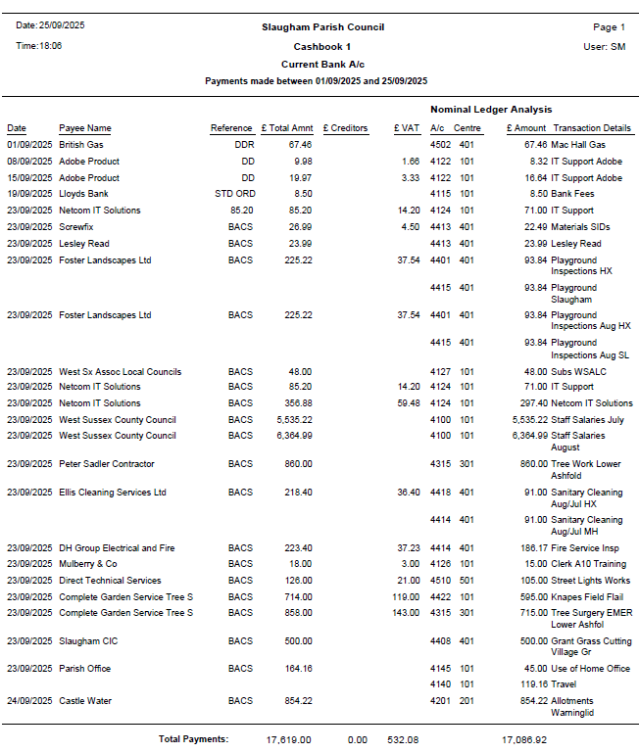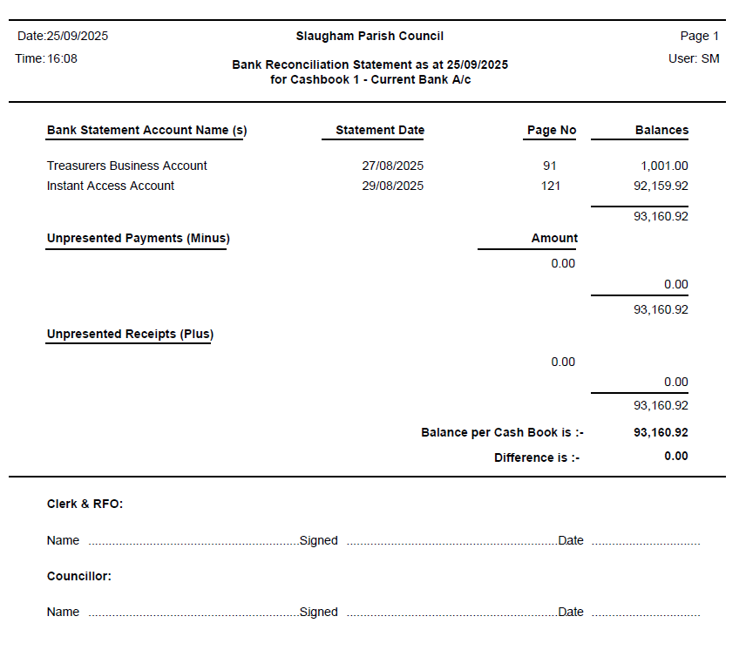

- Correspondence/Information Items/Publications/Consultations: (Correspondence cc’d in advance to members)

- Highways/Footpaths: to review highways projects/items: Members are asked to consider the following, papers cc’d in advance:
  - Bus Shelter – To update members of new/replacement bus shelters Pease Pottage It was noted that Cllr Marsh is meeting with developers to discuss options for repairing or replacing existing shelters, as well as the potential installation of an additional shelter opposite the Woodgate development.
  - To update members on the recent Traffic Regulation Order (TRO) Submissions - Members are asked to review and consider proposed Traffic Regulation Order (TRO) to introduce village gateway features and associated traffic calming measures Warninglid Lane.
Members received an update from West Sussex County Council regarding the Traffic Regulation Order (TRO) application for B2115 Warninglid Lane. Following a speed data assessment:
- It was confirmed that average and 85th percentile vehicle speeds are well below the national speed limit.
- No speed-related collisions have been recorded on this section of road.
- WSCC concluded that the current road conditions and data do not support a reduction in the speed limit at this time.
- Members were advised that perceived speeding concerns should be reported to Sussex Police via Operation Crackdown.
Residents have written to WSSC Highways raising the following points:
- Appreciation for WSCC’s prompt handling of the TRO application.
- Ongoing concern that vehicle speeds often exceed what residents feel is appropriate for the road’s conditions, particularly in the proposed 40mph buffer zone.
- Specific risks were highlighted, including blind summits, frequent flooding, sharp bends, and regular use by pedestrians, cyclists, and horse riders.
- Several recent accidents were cited, including collisions near Stanfords and Slatehouse Farm.
- A 40mph limit would help restrain excessive speeding and improve safety without encouraging faster driving.
- A request was made for a solid white line at Slatehouse Farm to deter overtaking on the blind hill.
While acknowledging WSCC’s position, residents continue to advocate for further calming measures and noted that Operation Crackdown is not a practical long-term solution.
  - To update members on proposed Traffic Regulation Order (TRO); Nymans are preparing a TRO that will be brought to the next convenient meeting.

Police / NHW Report / Resilience Group Reports

Crime Reports cc’d members – Updates issued to members in advance.

Any other matters that the Chairman wishes to raise for future discussion:

- Date of next meeting/s – 30th October 2025

Signed: Date:

