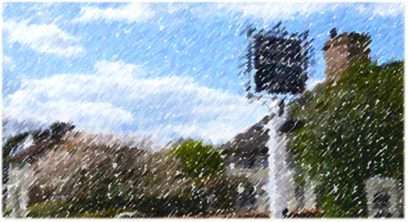
SLAUGHAM PARISH COUNCIL
RECREATION COMMITTEE AGENDA
Members are summoned to a meeting on
Tuesday 1st October 2024 at 7.30pm
Sports Pavilion Handcross
Email clerk@slaughampc.co.uk Website: http://www.slaughampc.co.uk _____________________________________________________________________________________

- Apologies for absence:

- To approve the minutes of the meeting held on the 9th July 2024

- To receive declarations of interest from members in respect of any items on the agenda.
- Open Forum: Council to consider adjournment of the meeting in accordance with Council’s Standing Orders:

- Management Committee Reports: to receive and note committee and advisory group updates – Committee to consider the RECOMMENDATIONS:

  - MacNaughton Hall Management Committee Updates/General: - To review current users and future requests for use of the site –
    - Members to consider and approve quote for additional fencing Mac Hall
    - Members to consider additional lighting quote

1. Supply and fit a 5ft pedestrian gate with furniture and spring closing latch.
2. Infill both sides of the existing posts with matching post and rail fence.
3. Remove all of the waste off the site.
Total cost £ 965.00 plus vat.
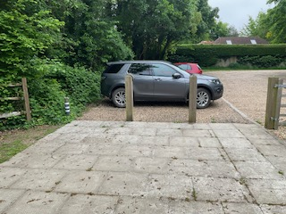
  - Sports Pavilion Management Committee Updates/General: - To review current users/costs and future requests for use of the site –
    - Football – Handcross & Lower Beeding – Members are asked to review the proposal for from the Club for use of the site 2024/25. cc’d in advance
    - Members are asked to approve drainage repairs quotes for the Pavilion.
    - Large event bookings conditions of hire and costs:
      - Rude Mechanical Theatre Company 10th July 2025

- Allotment Updates – To update members of status and progress:
  - Handcross – Rents received / Vacant
  - Warninglid - Rents received / Vacant
    - Recommend members approve clearance quotes
    - Recommend approve replacement fencing quotes
  - To update on rent increase recommended and lease agreements 2025/26

- Playgrounds: To update on reports and status:
  - Slaugham – Park Road, Slaugham
  - Handcross – Recreation Ground, Handcross

- HSE Risk Assessments – Committee to report on Risk Assessment Programme
Members to consider appointment of a facilities management service:

- Bus Stops – To report on new/replacement and repairs:

- Village Enhancement Projects: To update on projects
  - Public Toilets – To update on progress for renovation
  - Planting Bus Stop – Members are asked to review and approve quotes for planting.

- Knapes Field: To update on projects
  - Members to consider and approve initial clearance works to allow access to the site ahead of future works to be considered see below: Total cost £ 5865.00 plus vat.
  - Members to consider engagement ahead of works to allotmenteers and neighbouring properties.

1. Cut back the Conifer hedge on the entrance drive to allow proper access to the allotment.

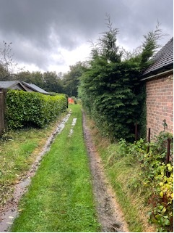
2. Clear the two allotments along the boundary to create a new entrance.

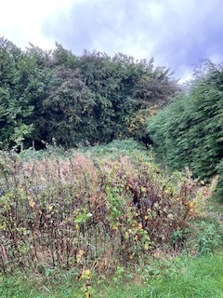
3. Remove a 12 ft wide section of the undergrowth and trees to allow access to the Knapes Field.

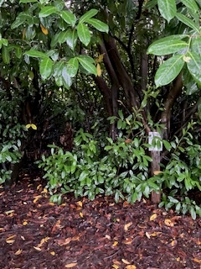
4. Supply, deliver and install a new 12 ft gate with lock.
5. Flail undergrowth to allow free movement around the site for the council to inspect the area.

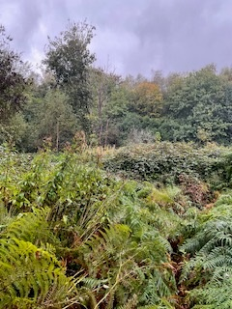
6. Remove any lower tree limbs to a height of 2-3 m to allow the tree stock to be inspected and assessed.

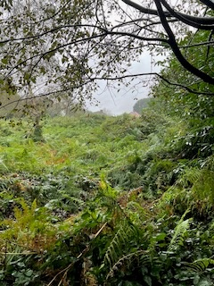
7. Remove all waste off site as required and leave neat and tidy.
- The Clerk to draft future management plan that will assist with the development and management of the open space, providing recreational opportunities that can improve public health and quality of life. This will enable Council to identify potential funding sources for land management improvement and future initiatives.
  - Members to consider conducting a survey among residents to gather input on the desired features and uses of a community field as per previous meeting.

- Update on the status of a request for additional permissive/public footpath linking St Martin, Park Road, Knapes Field.

- Other projects in progress
  - Common Land clearance and footpath works update:

- Matters for future discussion-

- Date of Next Meeting

