
SLAUGHAM PARISH COUNCIL
PLANNING AGENDA
The Committee Members are summoned to a Meeting to be held on
Thursday 20th April 2026 at 5.45pm in The Sports Pavilion, Recreation Ground, High Street Handcross
Sally Mclean – Parish Clerk clerk@slaugham-pc.gov.uk Website: http://www.slaughampc.co.uk Tel: 01403 733881
Press and Public are welcome to attend - The Parish Council is an open and transparent local authority and encourages public attendance at meetings.

- Apologies for absence: To receive and accept apologies for absence.
- Declaration of interest from members in respect of any items on the agenda: To record any declarations of interest
- Approval of the minutes of the last meeting: 26th March 2026, to receive and accept the minutes
- Adjournment for questions from the public: Members to consider adjournment of the meeting in accordance with Council’s Standing Orders, to receive questions from members of the public in attendance in respect of items on the agenda. To consider the following applications:

Ref. No: DM/26/0817 -Conifer - Fell 2 Preston Cottages The Green Slaugham West Sussex RH17 6AQ
Expiry Wed 22 April

Ref. No: DM/26/0377 -Pine Tree - Fell Chodds Farmhouse High Street Handcross West Sussex RH17 6BL
Expiry Wed 22 April

Ref. No: DM/26/0793 - Proposed 3m extension to an existing dropped kerb Hillbury Cottage Horsham Road Handcross West Sussex RH17 6DB Expiry Thurs 30 April

Ref. No: DM/26/0899 Oak - reduce canopy by 3m to promote new growth. Hollingbury Place Hollingbury Court Cuckfield Lane Warninglid West Sussex RH17 5SP Expiry Fri 01 May 2026

Ref. No: DM/26/0903- Proposal is for two permanent totem signs, with one located at the site entrance and the other located on the central green. Land East Of Brighton Road Pease Pottage West Sussex Expiry Wed 06 May 2026

- To note planning applications received after the agenda was published:
  - New planning appeals lodged with the Inspectorate: Planning appeal decisions:
  - Licensing Applications:
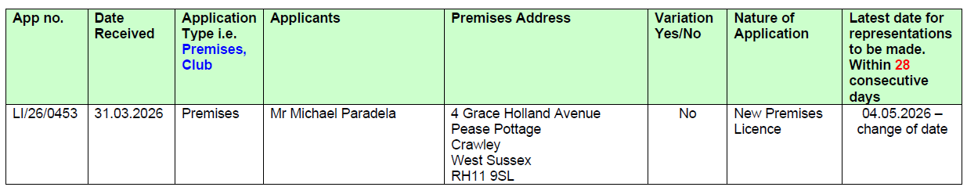
Licence LI/26/0453
Our Ref: LI/26/0377 Please see attached an application for a New Street Trading Consent for:
Fabs Fabulous Artisan Pizza Please provide any representations by 21st April 2026
  - Planning Enforcements Updates: Romanian Restaurant Site – Police site visit update
  - To note other planning matters: To include applications consulted under scheme delegation Local Government Act 1972:
- Mid Sussex District Council DECISIONs cc’d in advance:

- To consider Highways Matters to include but not limited to Public Rights of Way, Bus Stops

- Matters that the Chairmans wish to raise for future consideration:

- Date of the next meeting/s

