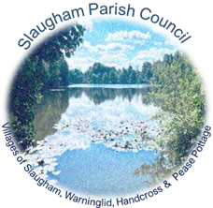

**Declaration to Accompany Accounts for the Year Ended 31 March 202**5

I, Sally Mclean, Parish Clerk and Responsible Financial Officer to Slaugham Parish Council, hereby declare that the status of the Accounting Statements are audited for the financial year ending 31st March 2025 as published.

**Signed:**

# S allyMclean

**Name:** Sally Mclean

**Position:** Clerk and Responsible Finance Officer

**Date:** 26th July 2025